THE YOUTH VOTE | USER FEEDBACK

Alexandra Lavin | Jemilla Scotten | Joanne Monaghan | Rana Khoury | Susan Bailey

**INTRODUCTION:**

User feedback was conducted with the site prototype on 14/08/2022.

Each user was selected to represent a youth-voter, and were given the following context -

“Your teacher has asked you to participate in a mock election, and given you poll cards to vote. Please give feedback on how easy you find the site to navigate and if you can achieve your aim of voting.”

**USER FEEDBACK:**

**Romy:**

Romy is 16 years old and lives in London. At the time of the report she had finished secondary school and was about to start A levels.

“I don’t know much about politics. I only heard about the Green Party two years ago. Before that, I thought Labour and Conservative were the only parties. I am curious about voting, which will be in just a few years for me.”

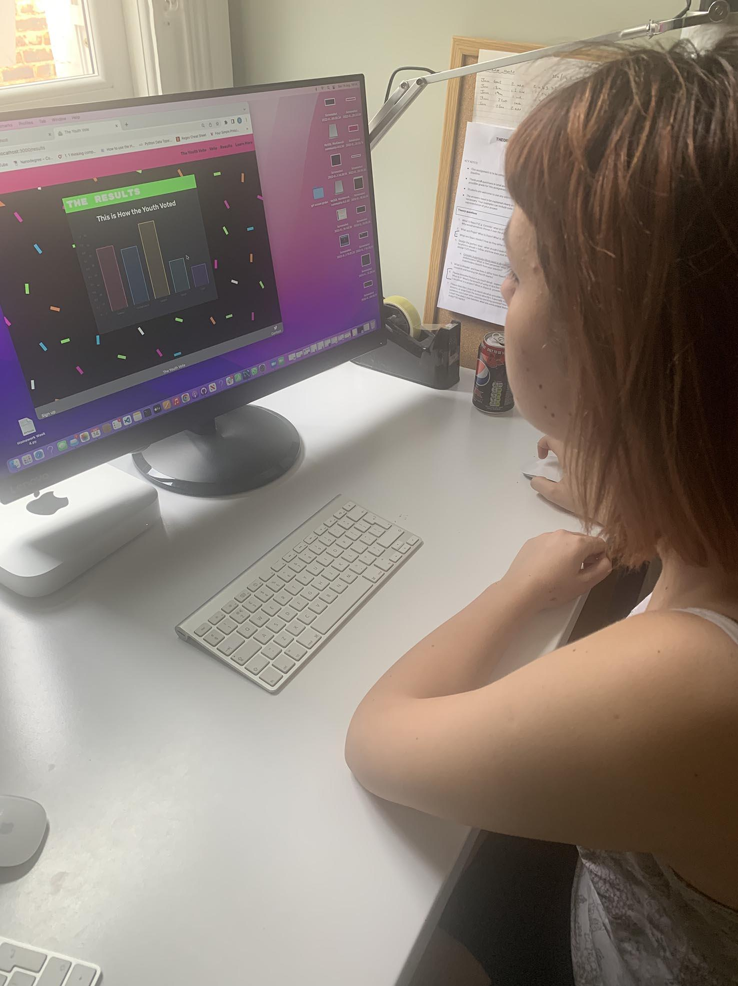

**Home Page:**

I love the design, this is very appealing. I like the language used, it seems quite adult. I like being referred to as a youth.

The whole prospect of having the chance to vote is very exciting. It’s nice to feel listened to.

The presentation is very clear. I can see exactly where I need to go, there aren’t too many overwhelming options, it’s simple so you can’t mess up.

I like how things move and change colour. It makes you feel like the computer does work.

It would be good on the home page to emphasize the power that is in your hands when you vote, maybe say in a few year’s time we can have our say, and how important it is we get familiar with the process.

I can see here I can go straight to vote, this is all very clear and I can see where I need to go. It’s like a normal website, but funkier. I can find my way around very easily.

**Vote page:**

I can see what I need to do. It’s very clear. I am just going to go to the Learn More page so I can find out more about these parties.

**Learn More:**

(Romy goes straight to the BYC Vote and starts researching, then returns to The Youth Vote.)

I like the look of the Learn More page, it’s fun. Not too much overwhelming info.

( returns to **Vote** )

Ok that’s very straightforward. It’s good you can see what happens next.

**Results:**

I like seeing the results straight away. I’d like to see what is happening in my school. If the party I wanted to win looked like it didn’t have enough votes, I could go round all my friends and ask them to vote, and then see if that affected the results. So it’s good you see the vote as you go along, so you could see if you asking your friends to vote would change things. I’d like to compare our school vote to the national youth results, and then the overall results. It would help us see if more young people voted how we could change the election result.

**Summary comment:**

Yes, it's a great site. I wish we had it at secondary school. Will this be used nationwide? I think it should, I think it’s important we all have access to something like this.

**Zach:**

Zach is 16 and lives in London.

At the time of the report he had finished secondary school and was waiting for his GCSE results.

“My parents have told me about voting, I sort of know what a poll card is and a polling station. I didn’t know normal votes are only on for a short time though.”

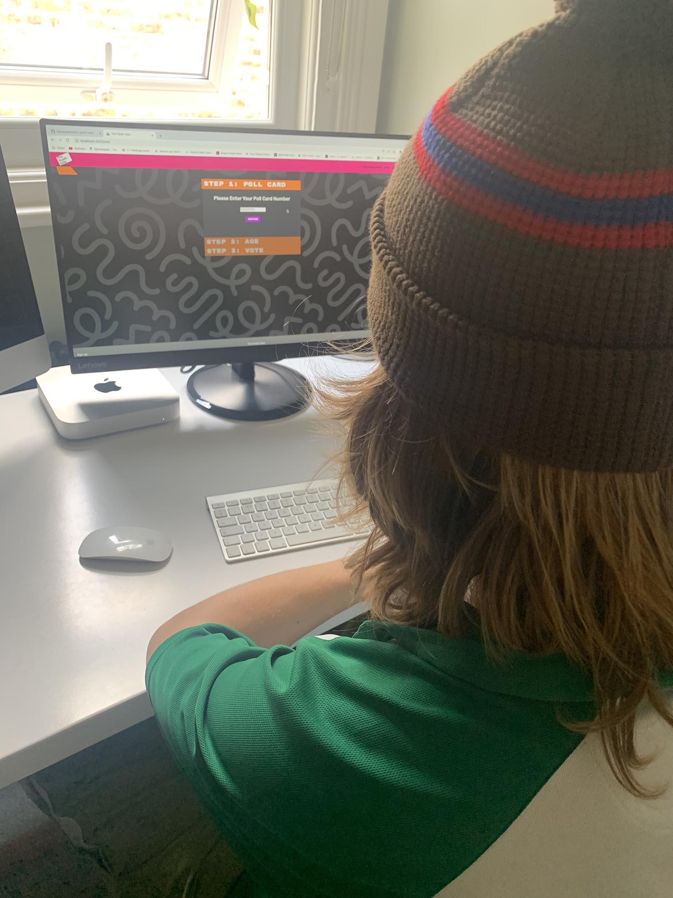

**Home Page:**

The site seems clear and simple, clear what you need to do. I can go straight to the ‘vote’ button.

I’d like more info on the homepage about why young people need to vote. I think it would be good to explain to people why they are doing this exercise. More about why we should vote, on this site and in real life.

The colours are great, good logo. It feels quite grown up but not too serious. I like the design a lot. Everything is here that I would normally expect, the logo operates like YouTube, you click on it and expect to see more detail about the person or group.

I can see where I need to go to vote, it would be good to have a bigger button. Maybe it looks different on a mobile, but on here it looks like it should be larger.

Do you have a sign-up page? You want people to follow what you are doing, I would sign up.

**Vote Page:**

This seems simple enough. I like the numbers. As long as the teacher had the pollcard it seems straightforward. It’s easier than buying something online.

**Results:**

Oh I didn’t expect to see the results. The idea is good, but the party names should be much bigger, and it looks quite faint. I’d like to see the results by school. I’d like to see a lot more results, bigger party names, I am not sure it’s clear enough. It’s simple to find but I am not sure what I am looking at.

**Learn More:**

Ah, I am not too sure what is going on here. What do I click on? It looks fun though. I don’t think I understand this page. I can see what it is but I am not sure what I should do with it.

**Summary comment:**

It looks really good and what is nice is that it's not condescending at all, the language and design. I’d be happy to use it, it would be a cool project at school to do.

**RAFE:**

Rafe is 15 and lives in London.

At the time of the report he had finished secondary school and was waiting for his GCSE results.

“I am studying sociology at school but we don’t learn about politics. I don’t know enough about it. I know Boris Johnson but that’s about it. I know what a poll card is because my mum takes me with her when she votes.”

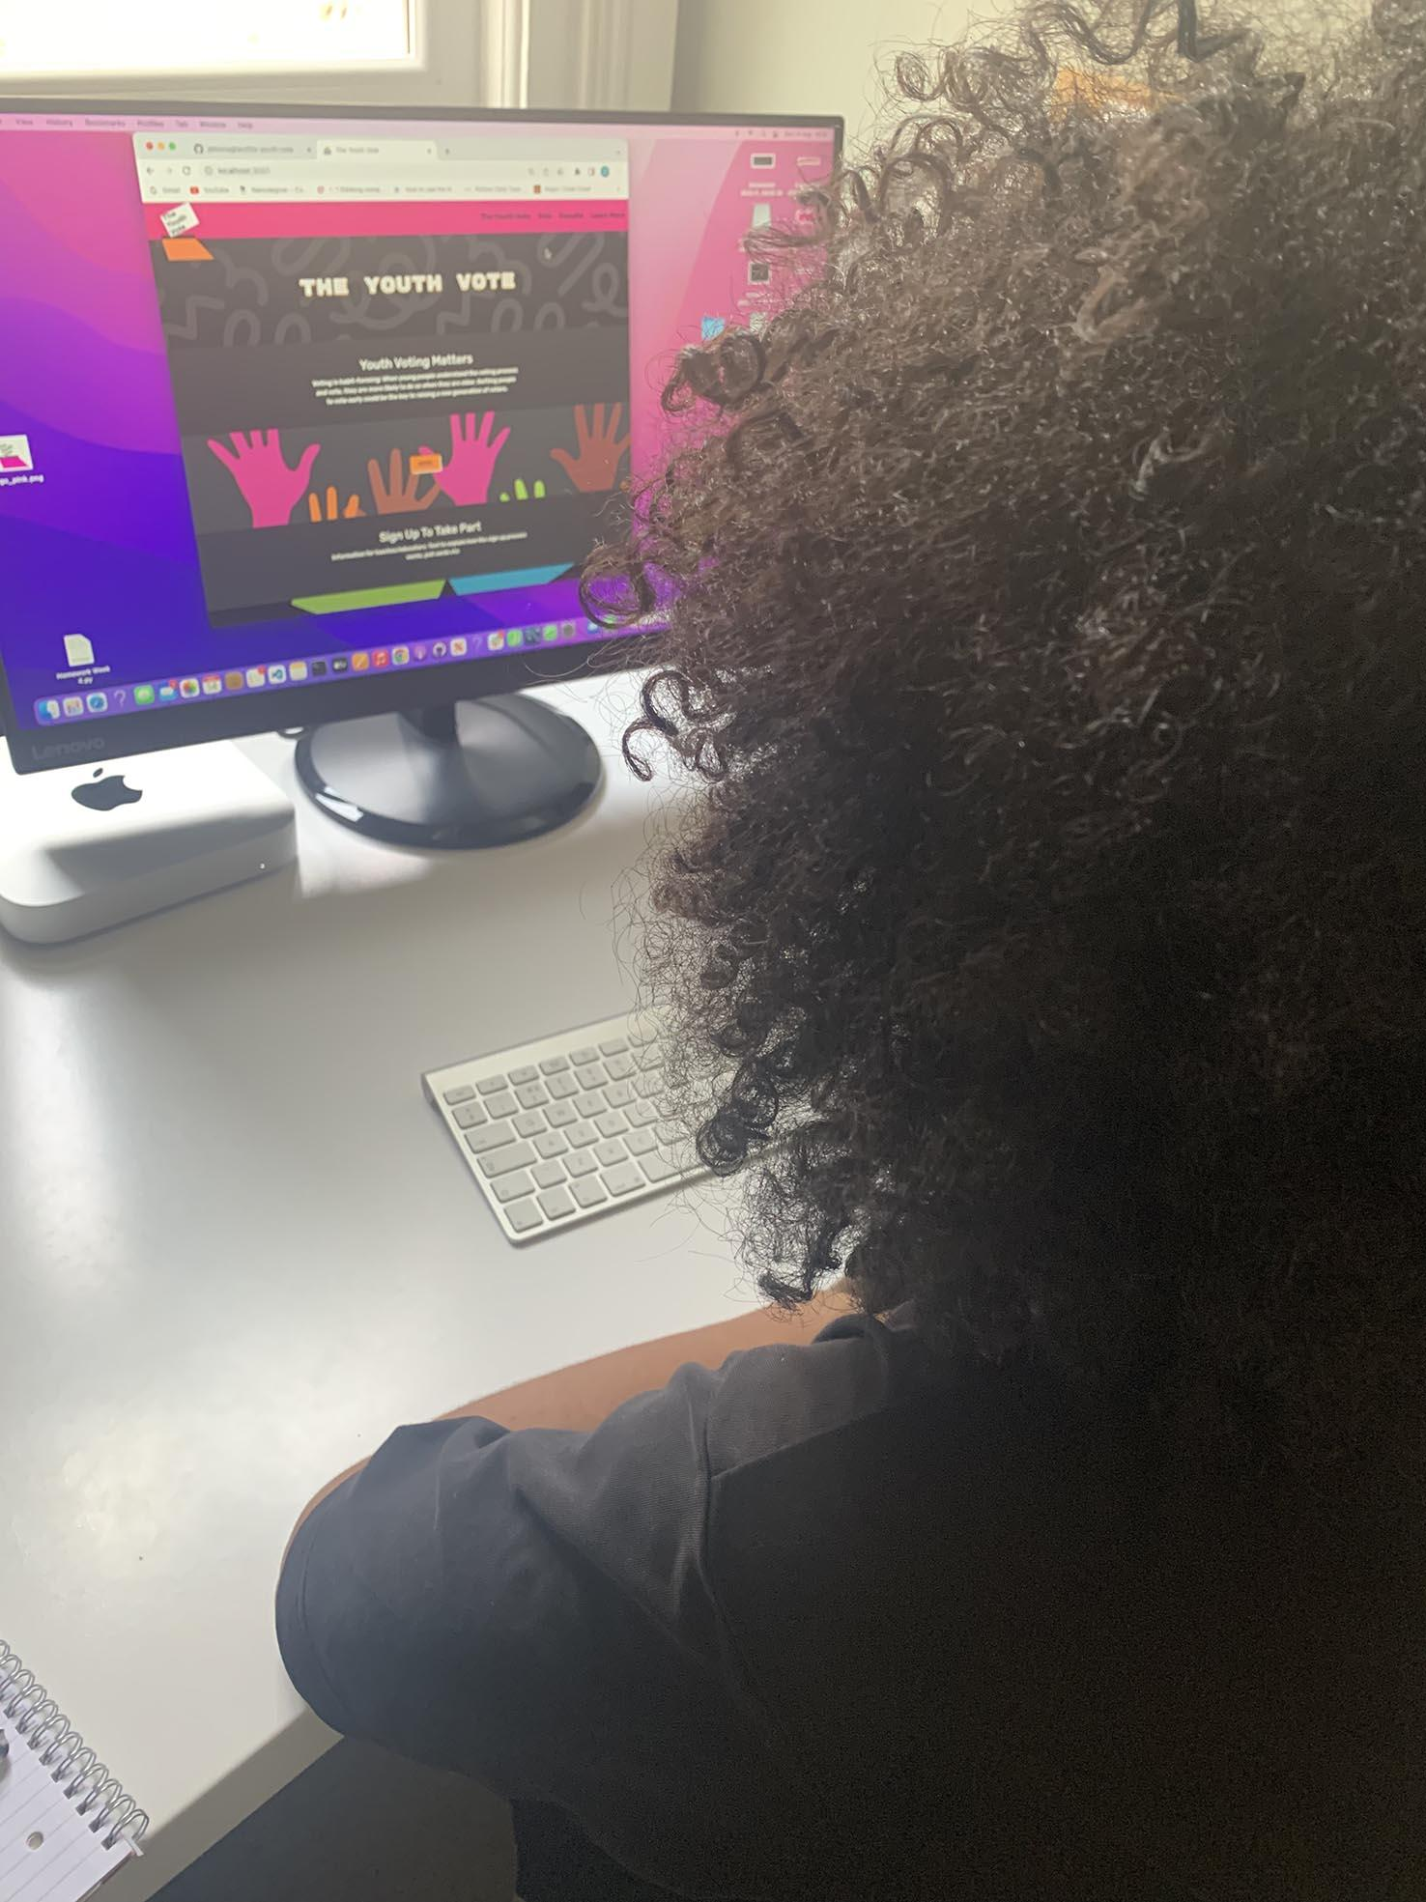

**Home Page:**

I am looking at the home page to see where I need to go. I can see the Vote button - is that where I should go? Let’s have a look.

I like the homepage. I like the hands. The general design makes me happy to see it, happy to use it.

I think the vote button should be larger. And the sign-up button should be next to it, so you can choose which one you need. All the links at the top and bottom make sense, they all look like what I’d expect.

It would be good to have more information on why we should vote, further down the home page or on another page.

**Vote:**

I like the colours here. We would have to help the teachers get the poll cards, some of them don’t know any tech at all. We may end up getting the poll cards ourselves and going straight to vote. We ( other young people ) can help them though.

**Results Page:**

From this I understand I get to see the results. I can see the parties but I am confused about the number values to the side of the results bars. Do they mean percentages or the amount of votes? It would be good to know. I can sort of see the results but I’d like it to be more clear about what the bars mean.

I’d like a sound effect or animation of confetti here, like a celebration.

**Learn More:**

This looks fun. Are these sites part of the same site? The movement is good.

**Summary Comment:**

The site looks good, I don’t think it’s too childish, the design’s about right. I’d be happy to use it and it would be an interesting thing to do at school.